This guide outlines the process of reporting a staff incident (resulting in an injury or near miss) in eduSafe Plus.
It is relevant to all Department staff as they are required to report injuries and near misses in eduSafe Plus.
Reporting a staff incident in eduSafe Plus
- Click on Home - eduSafe Plus link | Please note that your education login is required (not your BSC login)
- Click on Incident Report | 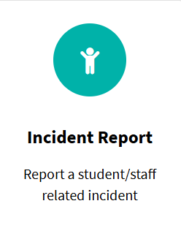
- Reporting an IRIS incident. Answer ‘No’ | 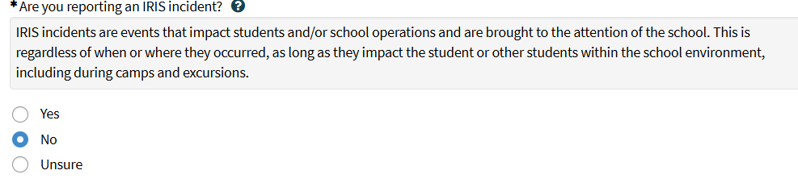
- Indicate whether the incident is an Injury or a Near miss | 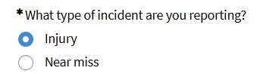
- Report Title: Provide a summary of the incident in a few words. Read information in box as this will guide you. | 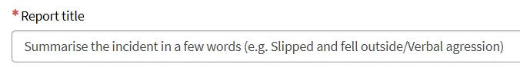
- Describe what happened. | 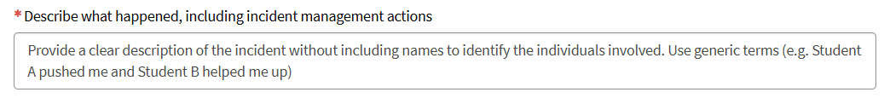  Do not use student or staff names in this field. This information is being sent to multiple parties  and must protect the privacy of the individuals involved.  Ensure you provide a succinct summary and use neutral language, with no explicit content. In your  description, you should include any actions you have already taken to manage the incident.  Near Miss only – If you selected Near Miss as the incident type, four additional fields will appear in this  section. Beginning with the first field, click on the down arrow and select the relevant option from the  drop-down list. Populate all mandatory fields.
- Location: select from drop down menu where it occurred  Location category: select specific location from drop down menu. | 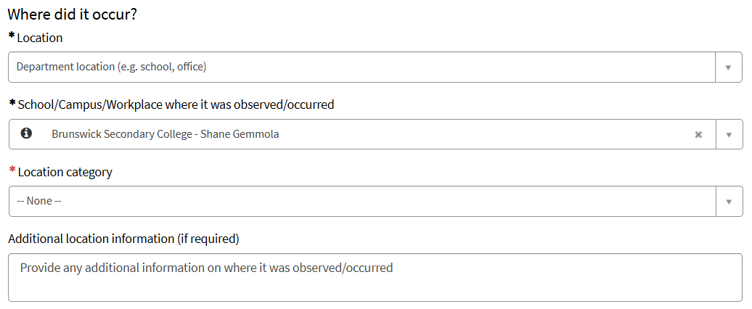  The Select the location type field is automatically populated with Department location (e.g. school, office).  The Enter the workplace field is automatically populated with your workplace. Update these fields if required.
- Indicate whether there was a ramp, stairs or equipment at the location | 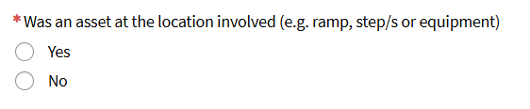  If you select ‘Yes’ in the Was an asset at the location involved field, you will be presented with additional mandatory fields to populate.
- Select the Frequency of the incident, either Single occurrence or Multiple occurrences. | 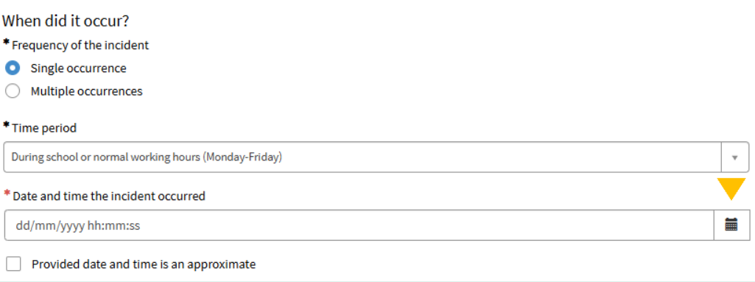  The Time period field is automatically populated with During school or normal working hours (Monday-  Friday). To select a different time period, click on the down arrow and select an option from the drop-down list.  Click the Calendar icon to populate the Date and time the incident occurred field. Select a date and time  using this feature.  Click on the Clock icon at the bottom of the pop-up window and select the time by clicking on the up and down  arrows. Click on the Calendar icon again and click OK.  If you select Multiple Occurrences, you will need to populate the From and To fields by clicking on each  Calendar icon and selecting a date and time.  If applicable, select Provided date and time is approximate.
- Affected person(s)  Click Add to open a pop-up window with additional  fields. | 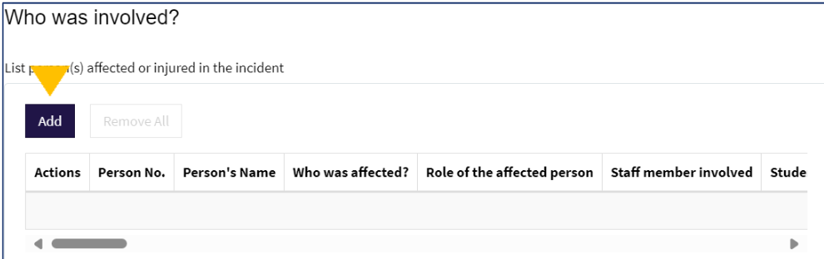  You can add multiple affected persons if applicable to the event.  The Who was affected field will default to Myself: this can be changed by clicking the Another Person button.  If you select Another Person, specify the Role of the affected person using the drop-down available.  Additional fields will appear depending on the affected person’s role.  Note: The affected person will NOT be notified automatically via the system. The reporter or workplace manager  will need to advise the affected staff members that this report has been logged on their behalf.
- Affected person: indicate whether there was an injury | 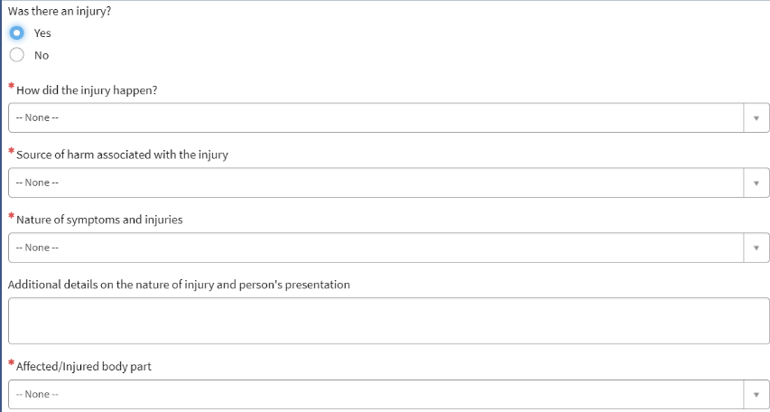  If an injury was sustained, then additional fields will appear.  Click the Add button at the bottom of the pop-up window to return to the form. The Affected Person will appear in the Persons affected or injured in the incident table.  To add additional affected persons, click the Add button again and repeat the above process.  You can edit or delete your Affected Person entries by clicking on the icons in the Actions column.
- Alleged causal party: specify a person who is allegedly responsible for causing the incident | Click the Add button to open a pop-up window with additional fields.  Populate all mandatory fields and click the Add button at the bottom of the pop-up window to add the person entry to the report.  Note: Alleged causal parties will not be notified or granted access to the incident form.  Note: Where an alleged causal party is also an affected person, a separate incident report will need to be submitted for them, as they will not have access to a report where they are identified as an alleged causal party.
- Witness: enter details of people who  witnessed the incident | Click the Add button to open a pop-up window with additional fields.  Select the Witness type by clicking on the corresponding radio button. Additional fields will appear depending on the value selected.
- Person(s) notified:  enter details of people who were notified of the  incident. | Click the Add button to open a pop-up window with additional to enter details of the parties notified  Select the Role of the person notified by clicking the down arrow and selecting from the drop-down list. Type their details in the following field titled Person notified.  The Time of notification and Additional information fields are optional
- Managing workplace | The Workplace managing the incident field is automatically populated with your workplace and workplace manager.  Note: The Workplace managing the incident is the person responsible for managing this incident. You can choose another person to manage the incident by selecting a different workplace and line manager. An example of when you may need to do this is if the incident involves your workplace manager.
- Attachments (optional) | To add attachments, click on Add attachments at the bottom of the form.
- Save as Draft (optional) | You can save the report as a draft at any time by clicking on the Save as Draft button on the right side of the page.  Reports saved as drafts are stored in the Draft List accessible via the header bar.
- Submit | Click the Submit button on the right side of the page once you are ready to submit the incident report.  After you click submit, you will see a confirmation page containing details of your report.  This report will now be visible on the eduSafe Plus home page in the My Reports: Incidents and  Hazards

Employee Wellbeing Support Services
The staff wellbeing supports available to you are known as Employee Wellbeing Support Services. (replacing Employee Assistance program - EAP). These services are free and confidential and will be delivered by external provider Converge International.
Services offered
The services are confidential and include a range of new supports - money, legal (non-work related), nutrition and lifestyle, conflict, career development, family advice, employee assist for counselling and manager assist for people managers. The new services will also provide 6 specialist helplines for staff who identify as Aboriginal and Torres Strait Islander, LGBTIQA+, a person with disability or carer for a person with disability, experiencing family and/or domestic violence, seeking advice on aged care issues or elderly family members care, and seeking spiritual pastoral care.
For an overview of the services, please refer to the fact sheet.
Booking an Employee Wellbeing Support Services appointment
Call 1300 291 071 or book online via the Converge International portal, entering the organisational code mywellbeing

